Front Rotor

Resources:
Gen11 Brake Rotor Thermal Analysis
- Theoretical hand calcs of rotor temp increase
Avg h Calculation - Consolidated
- Check the methodology of calculating h… the rotor is spinning so its not just a regular flat plate in parallel flow
Revised -> Avg h Calculation

Copy of Gen XI Brakes DR 04/30/2026
Tachyon Brake Rotor Thermal Analysis

CAD
Solidworks files (with static sim setup and results):
https://github.com/ProtonKicker/Gen11-Brakes/tree/main/front%20rotor

Or download the entire repo (cad in the “front rotor” folder)
https://codeload.github.com/ProtonKicker/Gen11-Brakes/zip/refs/heads/main

Pack and go zip with sims:
https://drive.google.com/file/d/1uz7ue5qlSUVNbMzDQWOVXulgLMQuHuCY/view?usp=drive_link

Sims
Input parameters:

Static Sims

Setup:
- 325 N*m on brake pad (each wheel)
  - AI annotated calculations: https://github.com/ProtonKicker/Gen11-Brakes/blob/main/Brake_Calcs_Front_Rear_1g_Max_Braking.ipynb
- At road-tire interface, mu=1.0
- Tire radius: 0.279m

- Break pad positions offset by 15 deg

Results:
- FOS (min) = 1.2
- Weight: 1.64 lbs / 0.74 kg

- Apparently reversed direction has the same FOS for some reason

Position 1 (FOS 2.3)

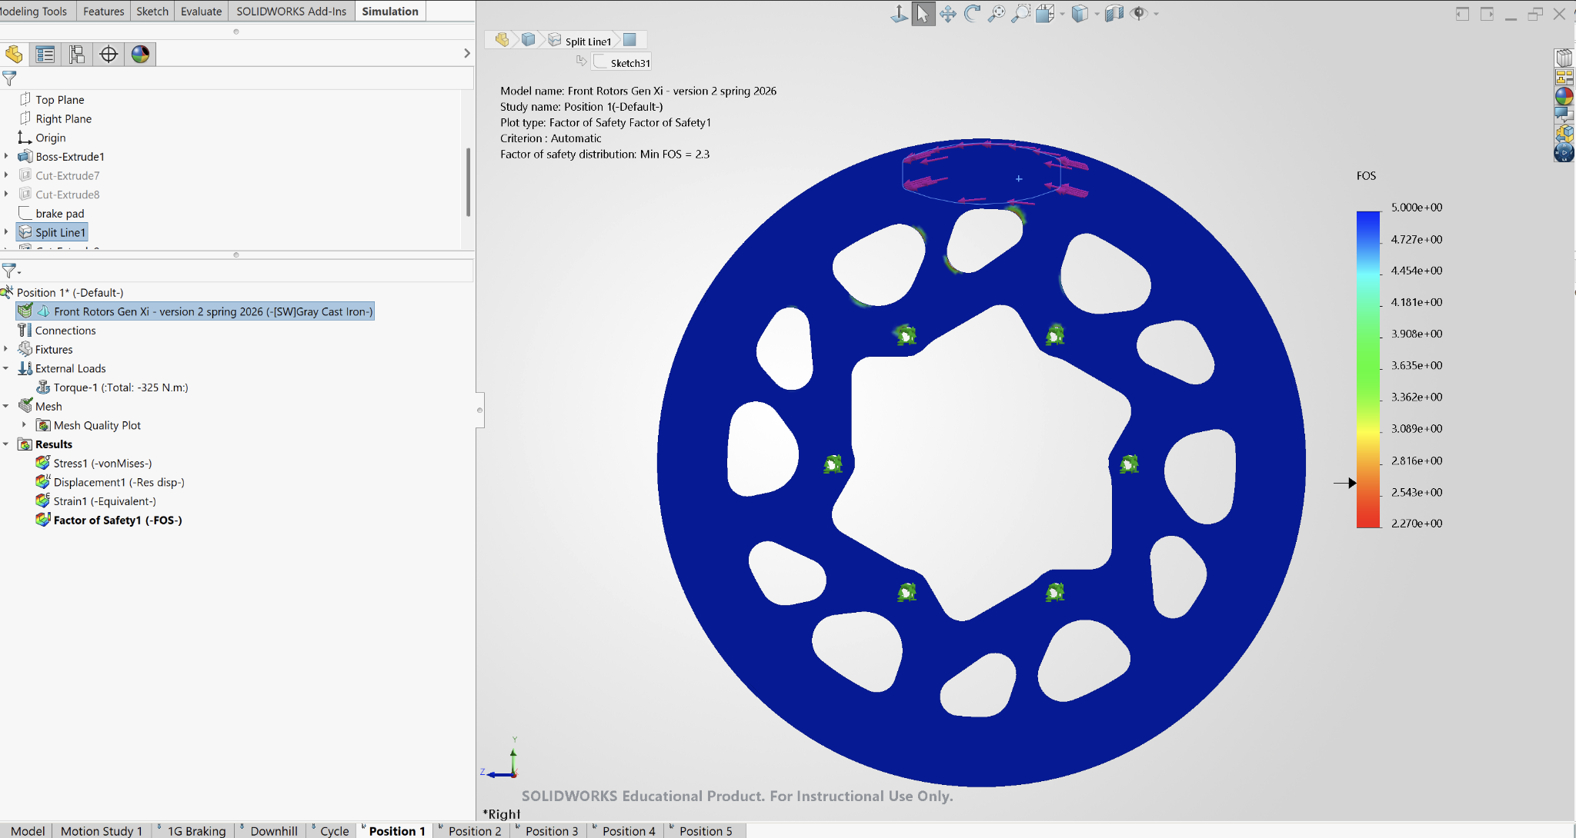

Position 2 (FOS 1.3)

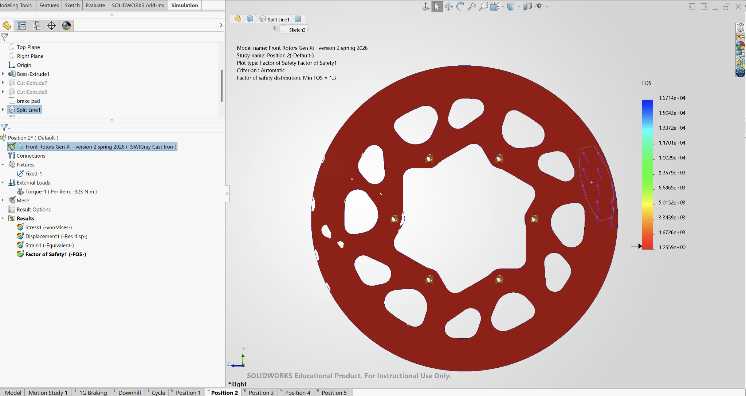

Position 3 (FOS 1.2)

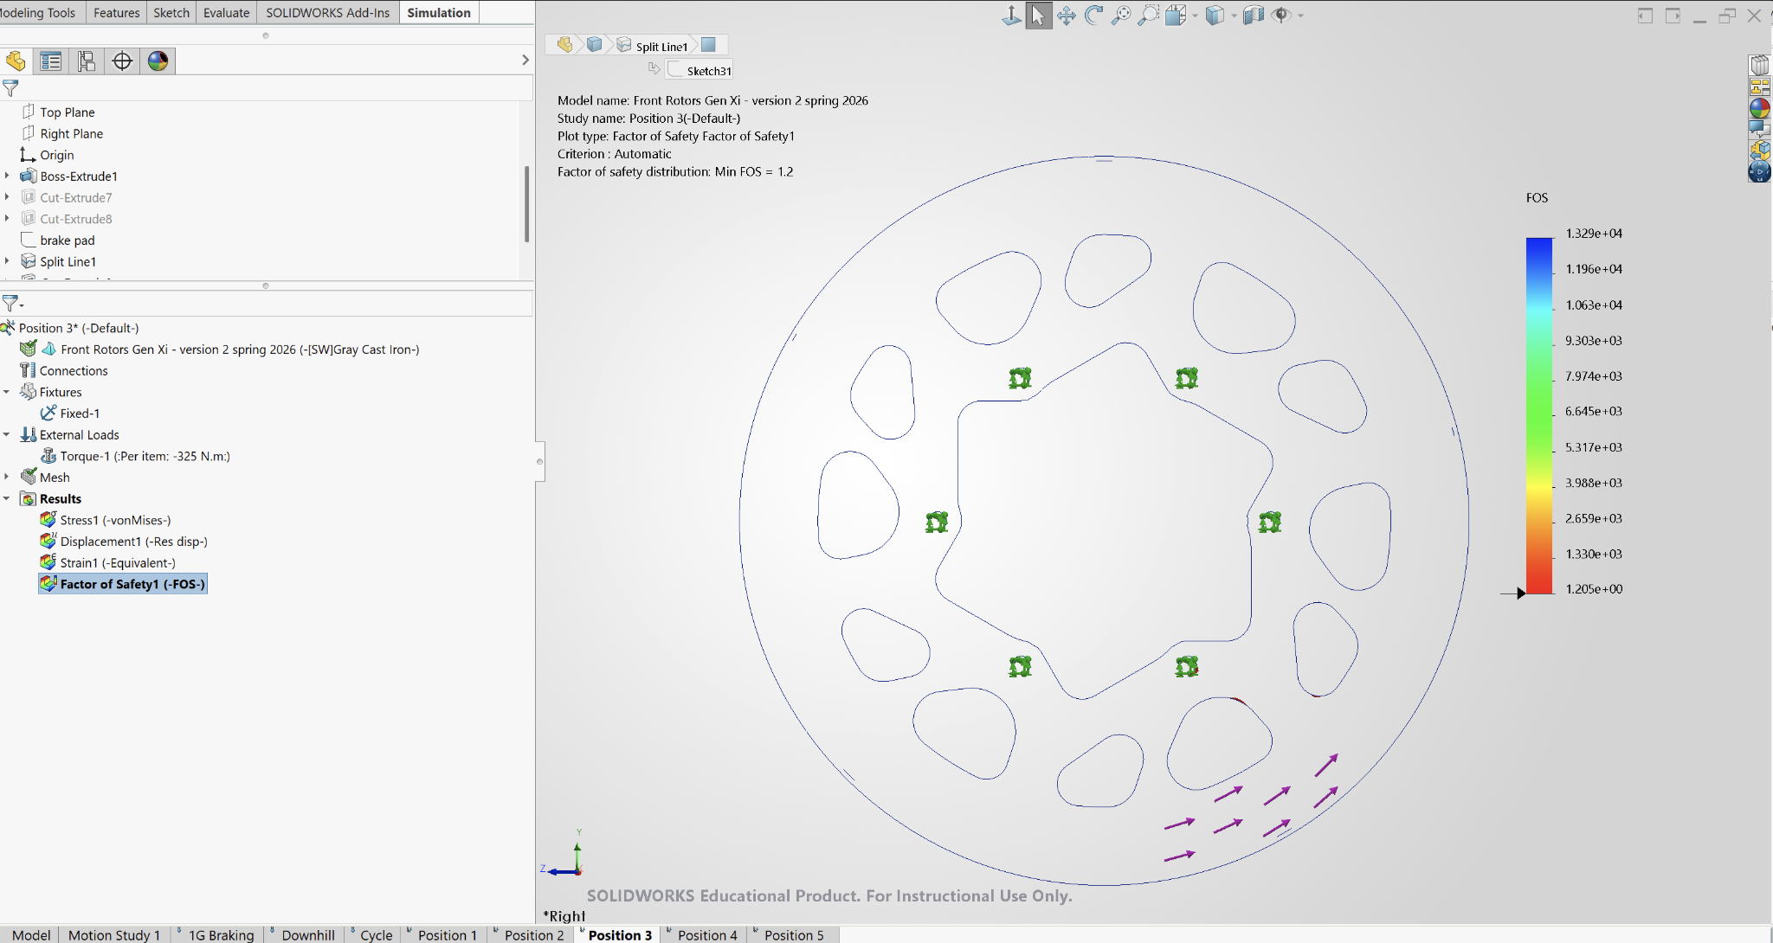

Position 4 (FOS 1.2)

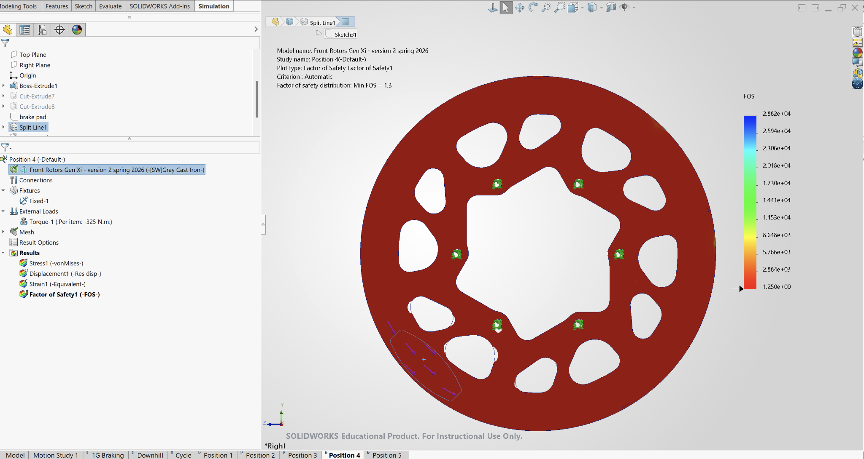

Position 5 (FOS 1.2)

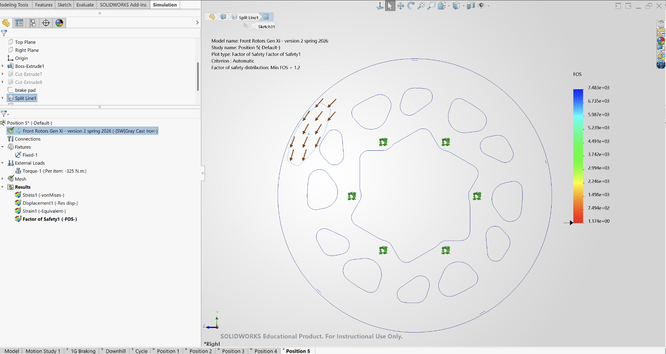

Thermal Sims

Setups:
- Ambient Temperature: 310.93 K (100°F / 37.8°C )
- Pr = 0.707, h = 43.98482061

- Finest mesh

1g braking

Assumptions:
- 30 m/s speed, 1g slow down
- 183kg on the front

Result:
- 472.0 K / 198.85 °C / 389.93 °F

Notes:
- 0.05s interval, t = 3s

Temperature Distribution

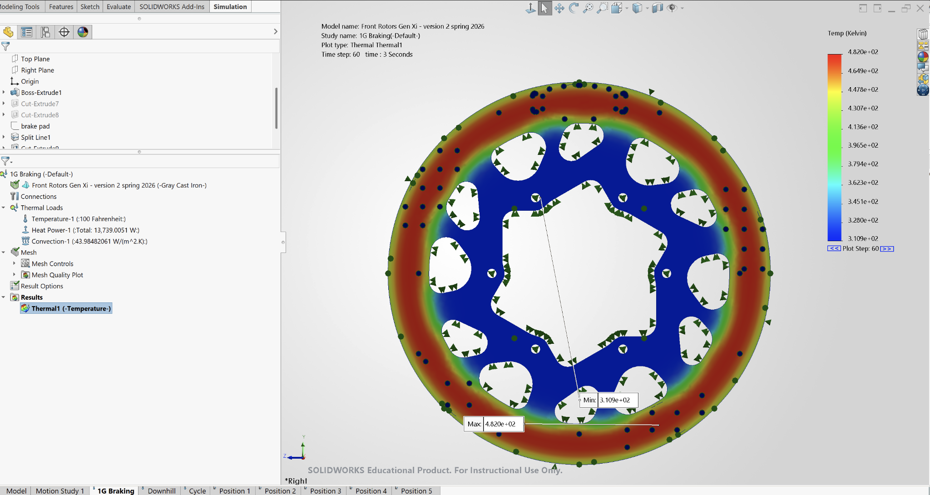

Temperature vs Time

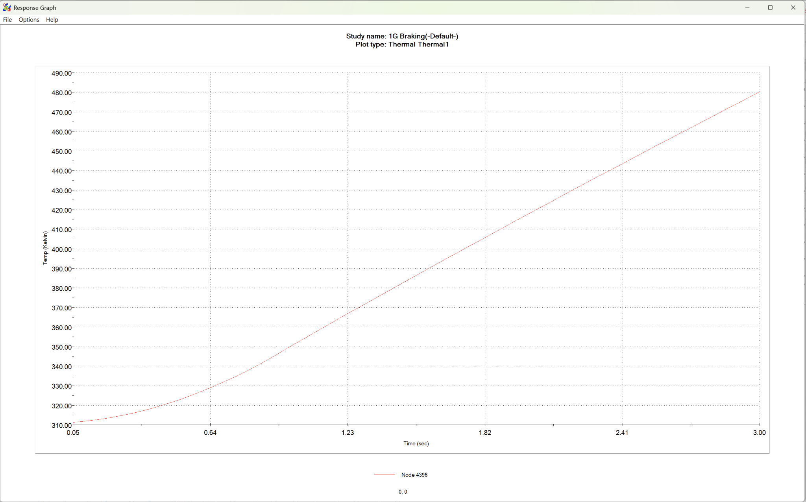

Continuous downhill braking

Setups:
- 25 m/s speed, 15 deg hill angle
- 1826.41N on the front or 913.205 N on each front wheel
- Radiation emissivity 0.8

Result:
- 1km at 30m/s until thermal shock threshold is reached

Temp distribution at t = 30s

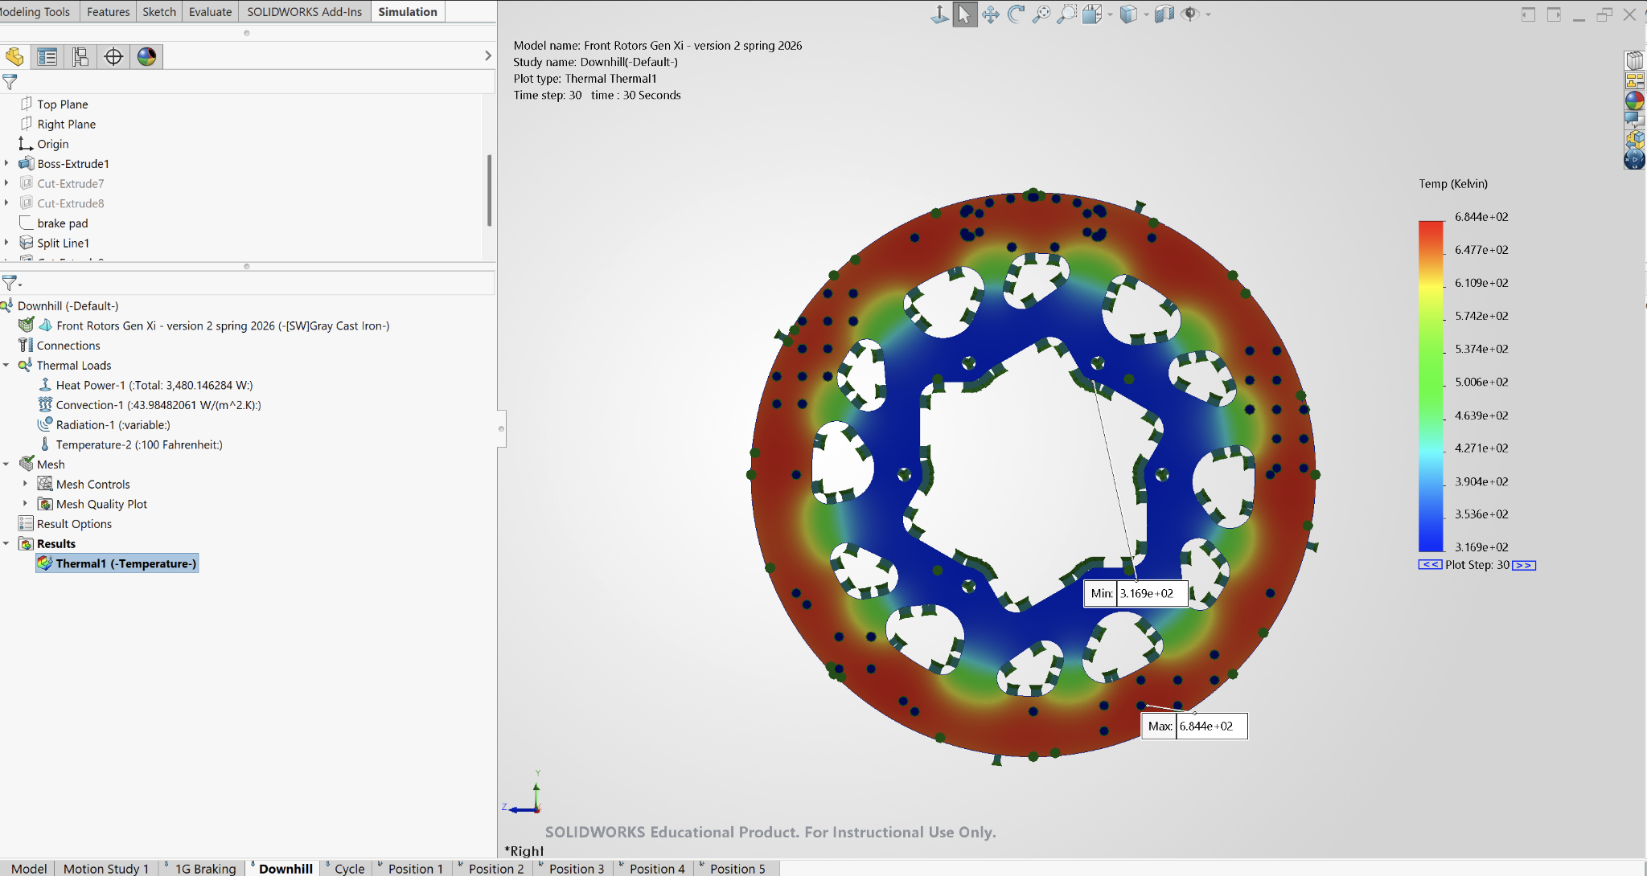

Temperature VS Time

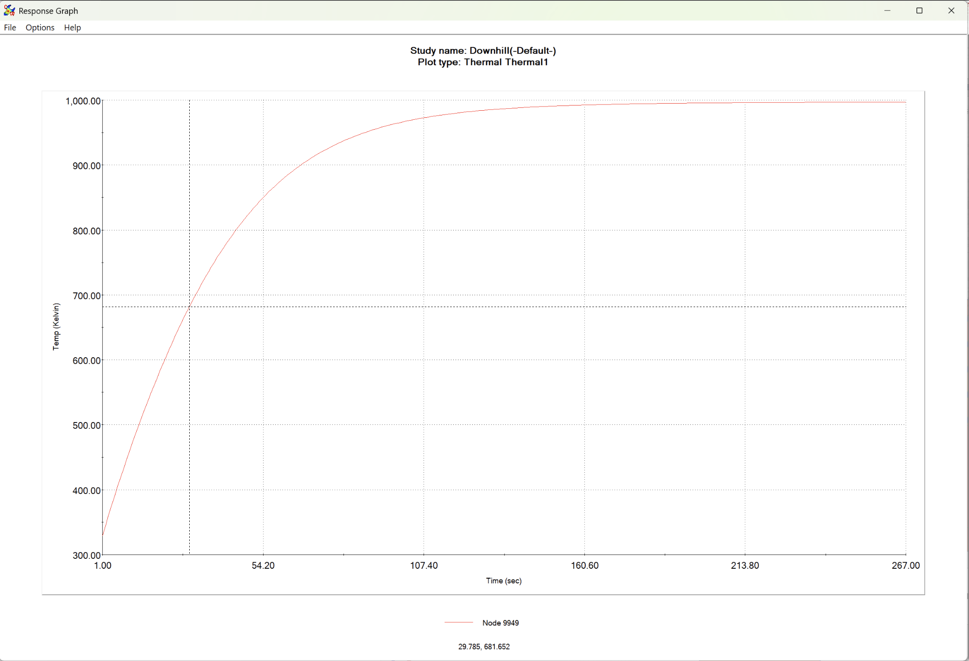

Repeated Duty Cycle

Setups:
- 0.2g accel when gaining speed
- 30m/s 1g braking
- 60s, 3 cycles
- Radiation emissivity 0.8

Heat Power (braking power)👇

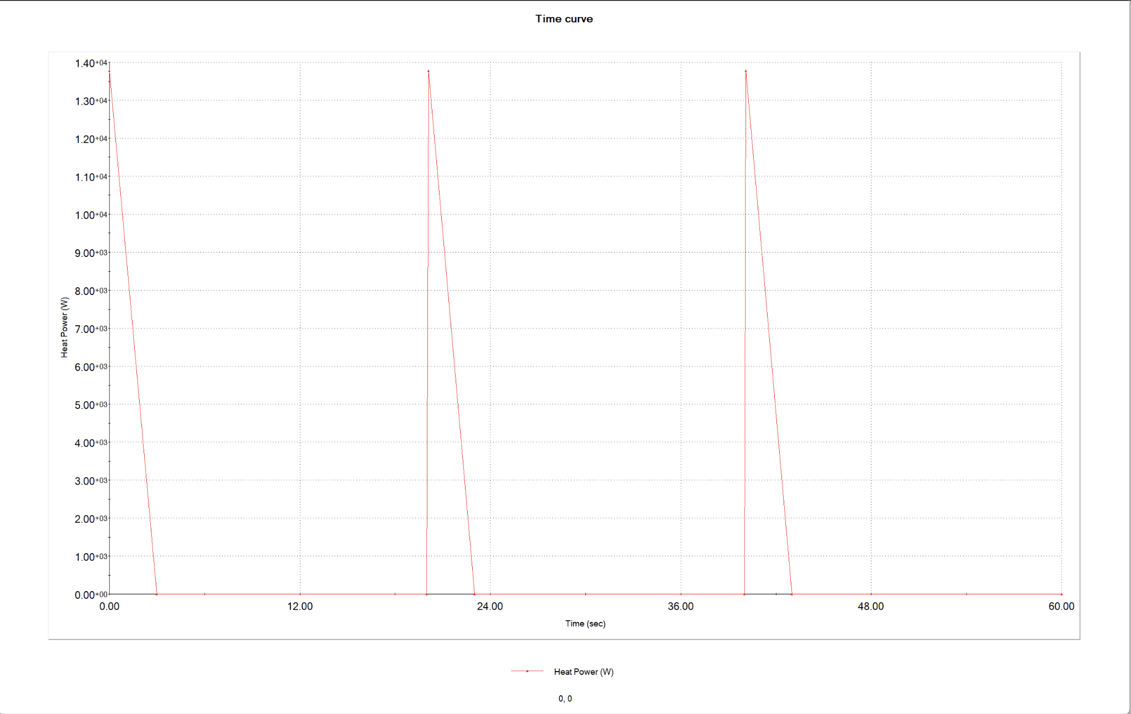

Convection (h)👇

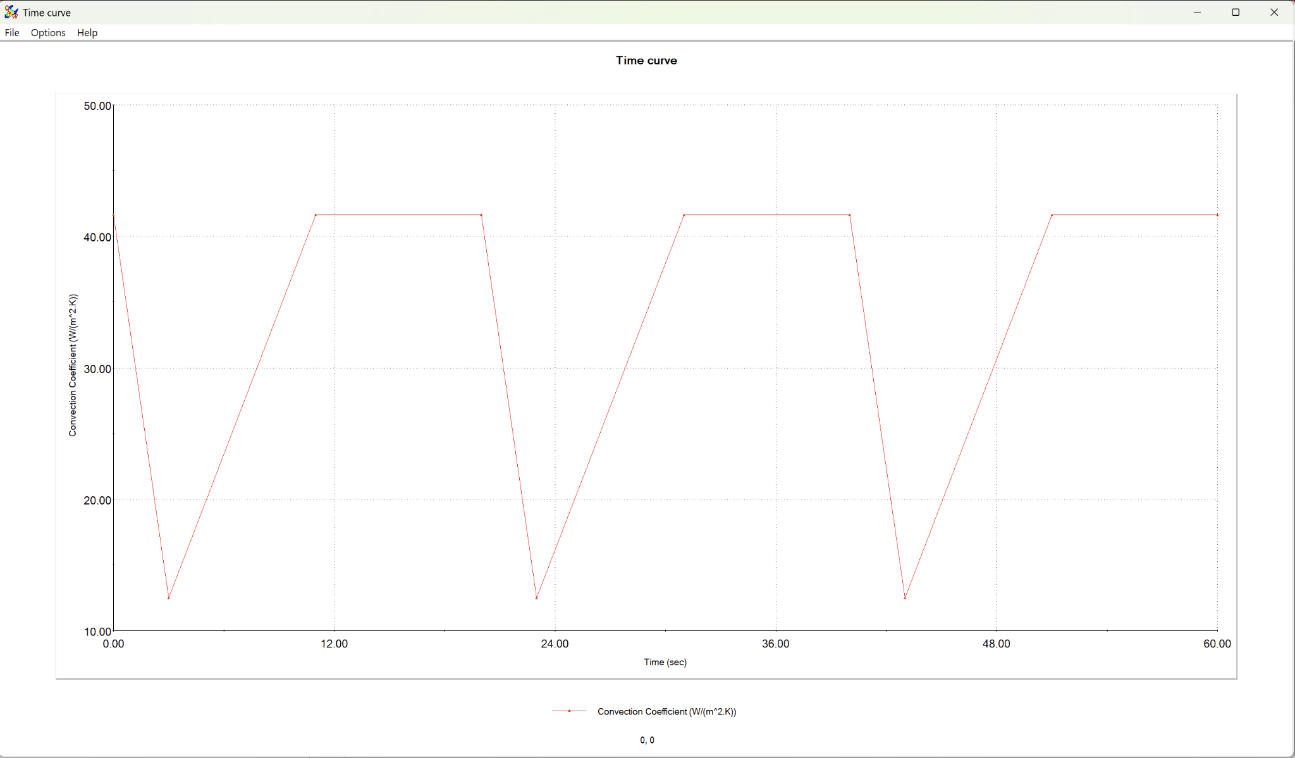

Results:
- 529.1 K / 255.95 °C / 492.71 °F

Temperature Distribution (Peak at 42.7s)

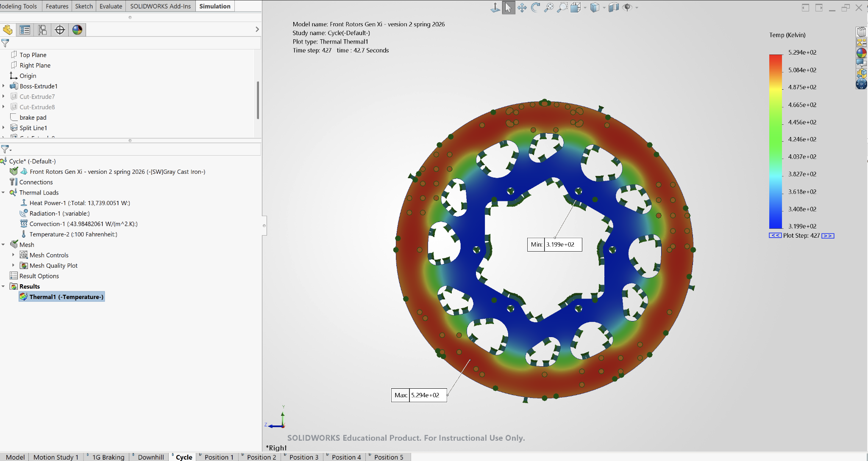

Temperature VS Time

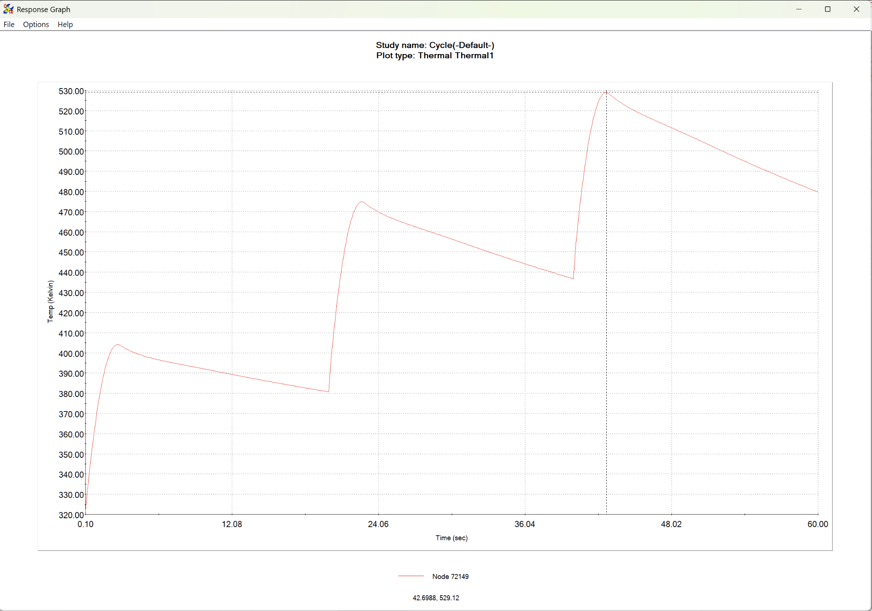

Static Sims

Setup
- max braking force for front: 2327 N (at 1g weight transfer)
  - https://drive.google.com/file/d/18nv-dQ59la7i7q2jPzx00HYS4iSGQYc5/view?usp=drive_link for weight transfer calcs
  - At road-tire interface, mu=1.0
  - Tire radius: 0.279m
  - Torque = 650 N*m

Static 1
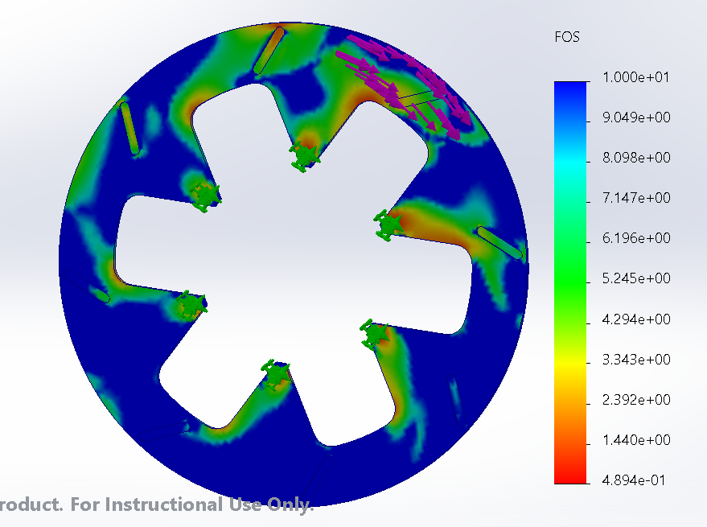
- Min FOS .49

Static 2
- Made it thicker (.1875”)
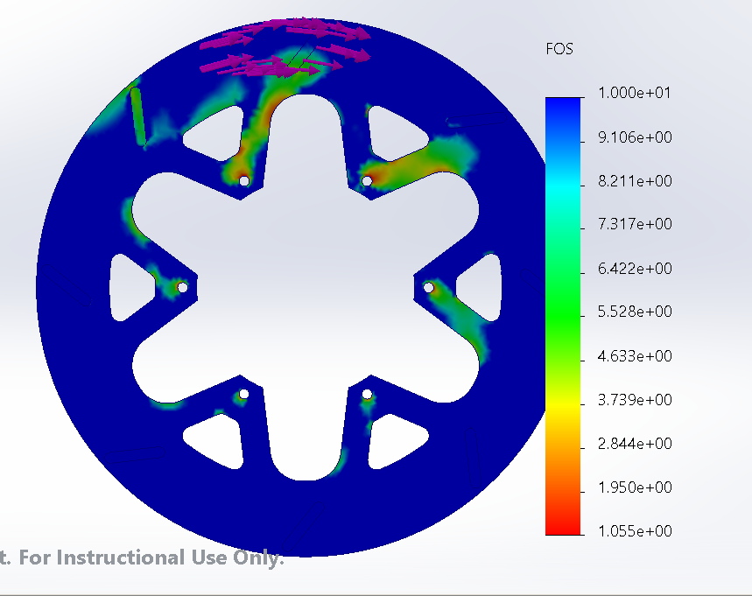
Min FOS: 1.06

